**1 - ServiceNow Scripting Full Course**

The video discusses key aspects of scripting and customization within the ServiceNow platform, focusing on both client-side and server-side scripting. These scripting techniques are essential for developing and customizing functionalities within ServiceNow, including creating custom widgets, implementing fixed scripts, and controlling access through ACL scripting.

**ACL Scripting -** Access Control List (ACL) scripting is a crucial part of server-side scripting in ServiceNow. It is primarily used to control access to records or fields based on user roles and permissions. By leveraging ACLs, administrators can specify which users have read, write, or delete permissions for specific records. ACL scripting involves checking user roles and the associated rules before granting access, ensuring data security and integrity within the platform.

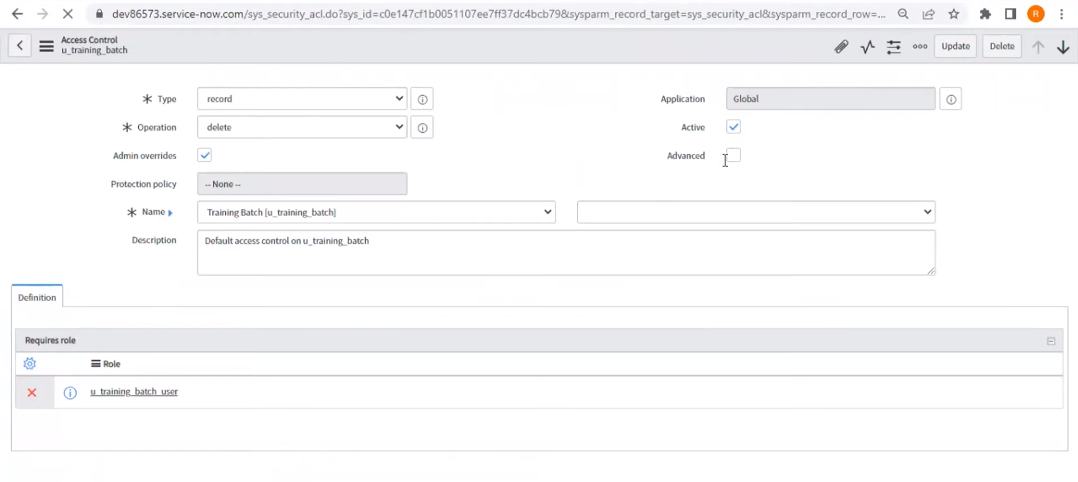

**Client-Side Scripting -** Client-Side Scripting, on the other hand, focuses on the browser-level interactions and visual modifications that users experience. It is used for cosmetic changes to the user interface, such as showing or hiding fields, auto-populating form elements, or dynamically modifying forms based on user inputs. Client-side scripts execute on the browser and include tools like UI policies, client scripts, and data policies, making the user interface more interactive and responsive. The distinction between client-side and server-side scripting is made clear: client-side handles front-end operations while server-side handles backend processes like querying databases or manipulating data not visible to the user.

**Fixed Scripts -** Fixed scripts are a type of server-side script that is used to execute code for specific, one-time processes. While it shares similarities with background scripts, fixed scripts can be saved and moved across different environments using update sets, which is particularly useful when dealing with large-scale data updates or migrations. For instance, a fixed script might be written to query a set of records and make bulk updates or corrections based on certain criteria. Unlike background scripts, fixed scripts are easier to manage across different ServiceNow instances.

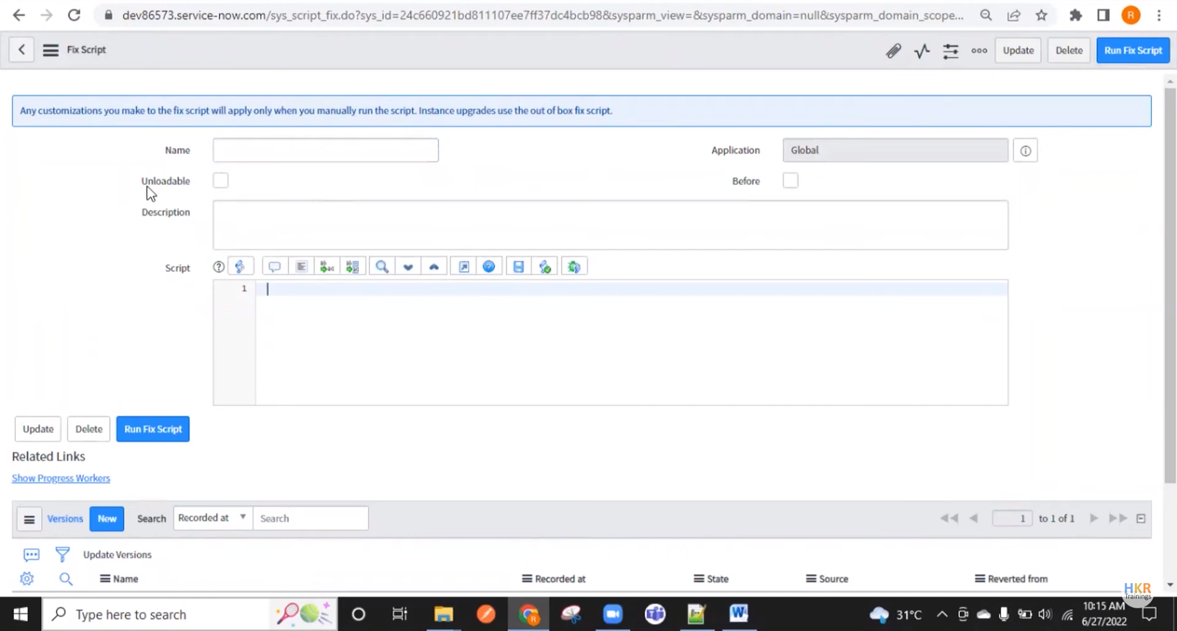

**Customizing a Widget -** Customizing widgets in ServiceNow involves a combination of both client-side and server-side scripting. Widgets are key components in ServiceNow's Service Portal, providing users with a dynamic interface for interacting with data. Customization allows for modification of widgets to meet specific business needs, such as altering how data is displayed or how users interact with forms. Widget customization requires proficiency in HTML, CSS, as well as ServiceNow-specific client-side and server-side scripting. Data transfer between the server and client side often involves Ajax and Glide records, ensuring that the relevant information is displayed in real-time.

ANANYA CHOUDHARY